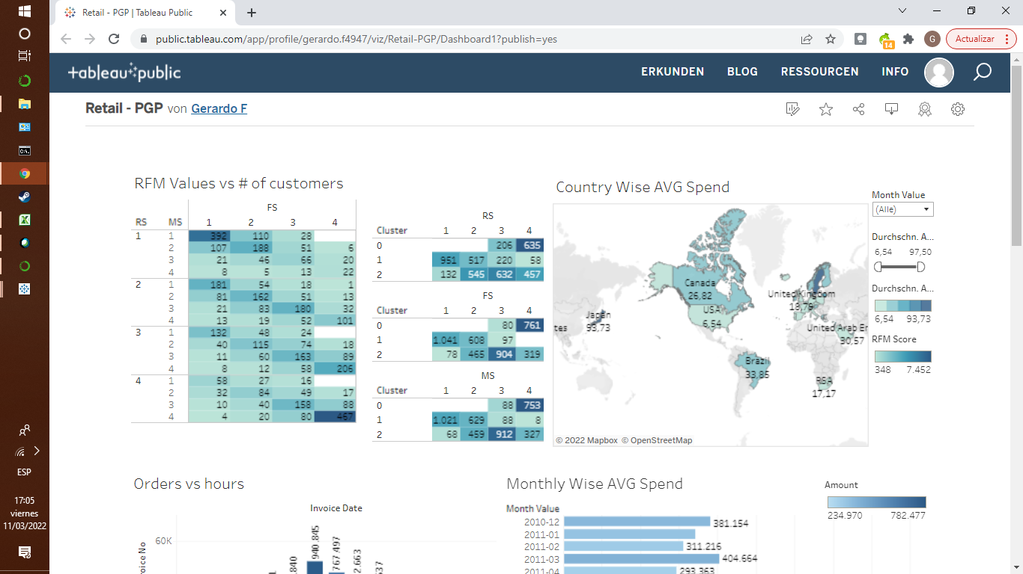

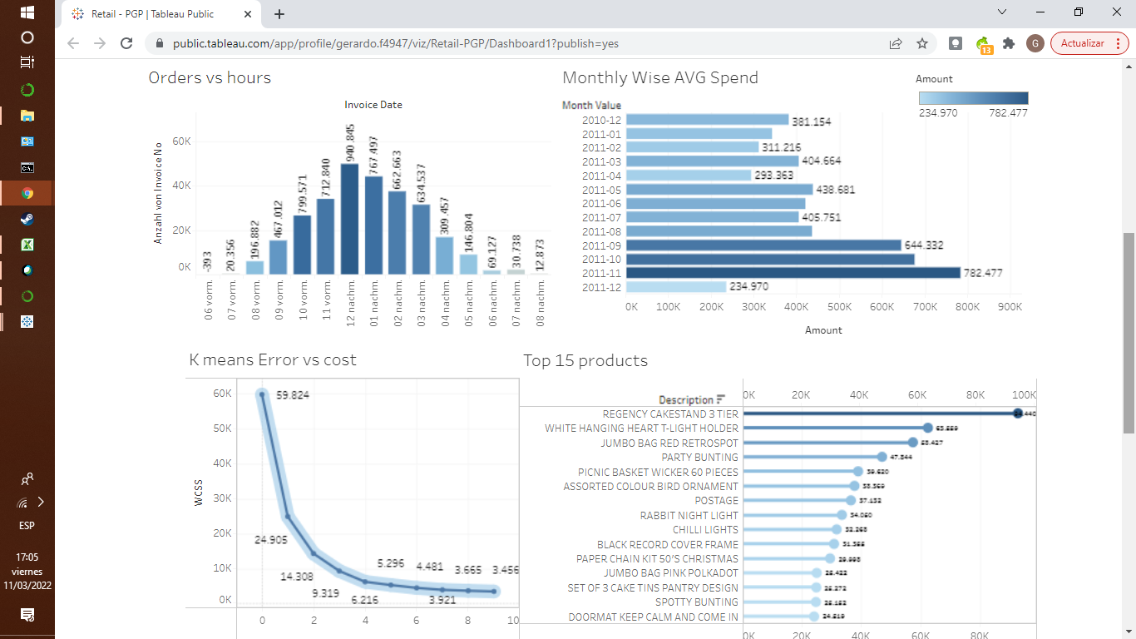

Source:<https://public.tableau.com/views/Retail-PGP/Dashboard1?:language=de-DE&publish=yes&:display_count=n&:origin=viz_share_link>

Insights:

* Japan (93,733) and sweden (87,531) are the companies with the higher average spend, and thus, represent the company's biggest market
* According to the “RFM values vs #of customers” chart, the company's biggest niches are its best customers with a Recency, frequency and score of 4. 467 costumers were found in this category
* According to the “Orders vs hours” chart, the company´s customers made the most purchases between 12:000 p.m. noon and 3 p.m.
* According to the “Monthly Wise AVG Spend” chart, the last 4 months of the year were the ones where the company achieved the highest profits. For december it must be taken into account that only the first 10 days were provided, and thus the month was not yet complete.
* According to the “Kmeans error vs cost”, the optimal number of clusters was 3, providing the most significant inertia.
* Finally, the top 3 products bought were Regency cakestand 3 tier, white hanging heart light holder and jumbo bag red retrospot with 94 440, 63 559 and 58 427 units sold for each.